UNIZAP’s Quick Picture Add-on lets you set photo in your CRM records. This is very useful when you want to display Contact photos on CRM form.

This blog post provides installation & setup information for Quick Picture Add-on

**Step-by-step guide to set photo on Contact form:**

1. Install Quick Picture by importing the managed solution into your CRM System.
2. Open Form customization window in Contact Entity & navigate to Insert Tab to insert a new Web Resource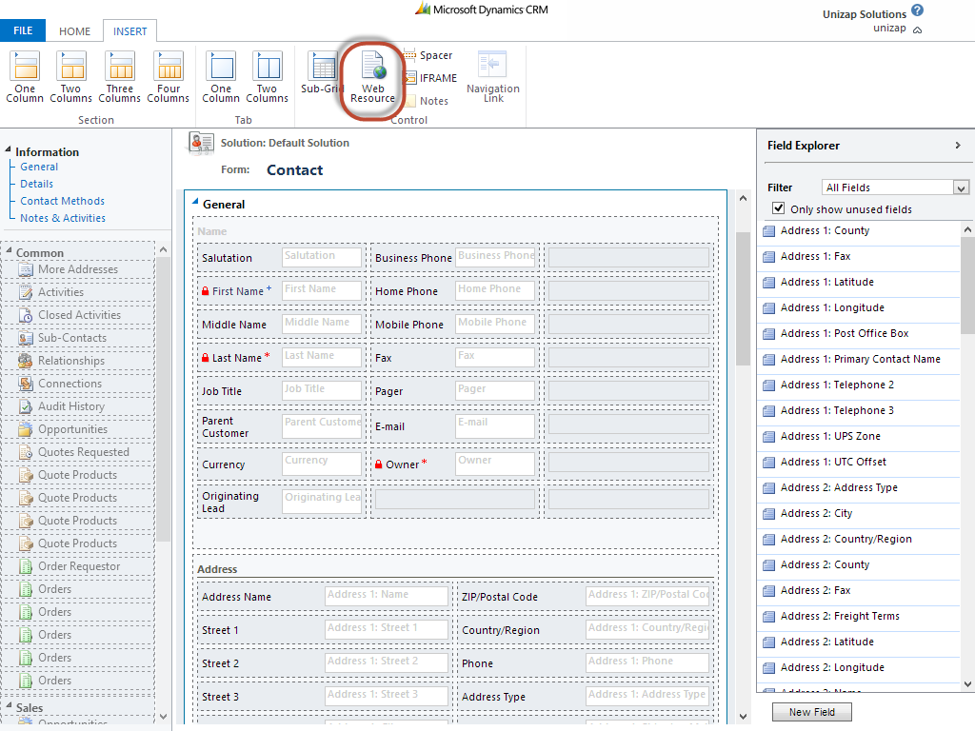
3. Add *unizap_QuickPic.html as* shown in the following images.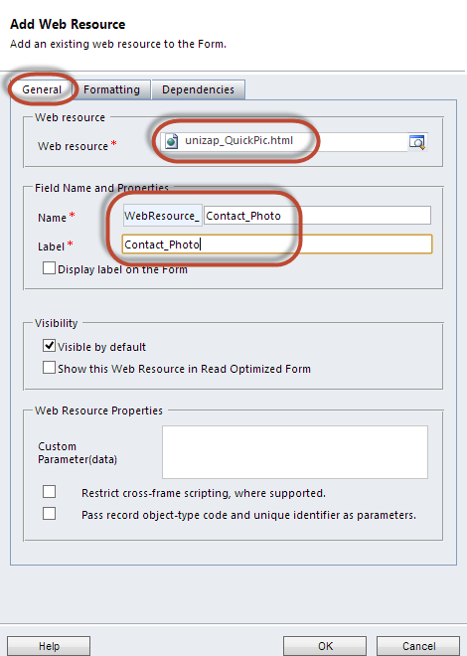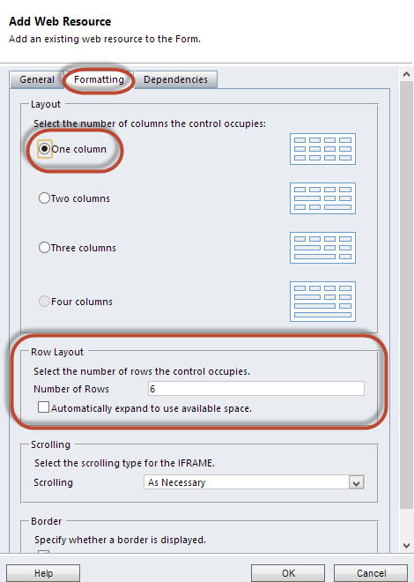
4. After you insert the Web Resource the CRM Contact form should look like this. Save & Publish to continue.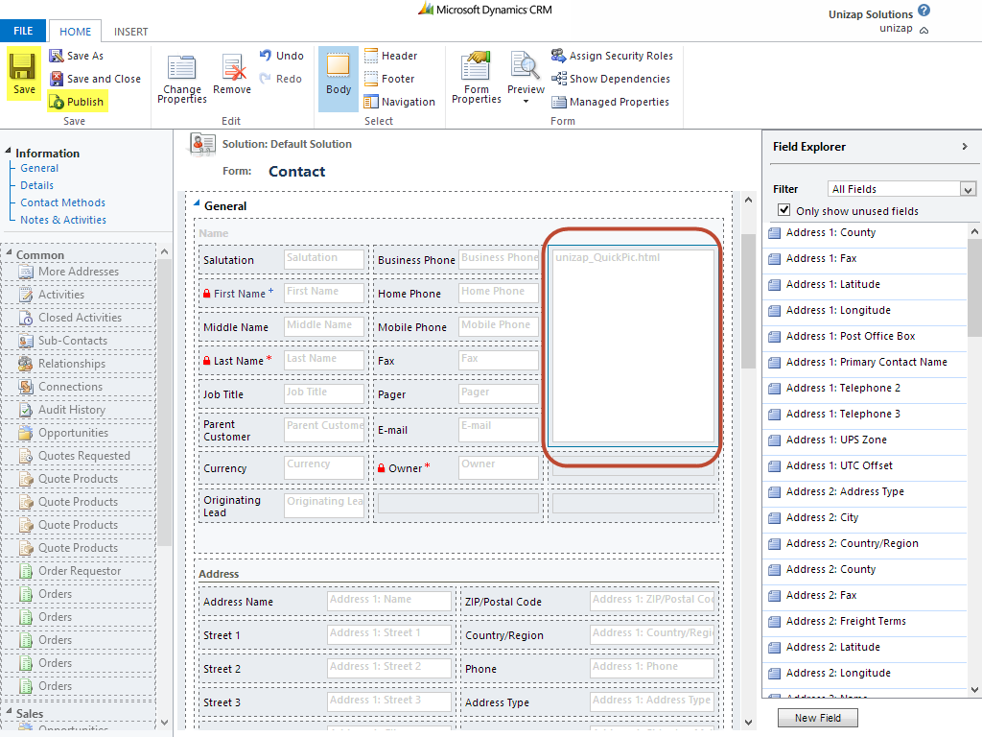
5. Now open any Contact record from your CRM system to see the Quick Picture Placeholder as shown here. Hover on the Placeholder to get access to *Choose File*  button as shown in the screenshot below.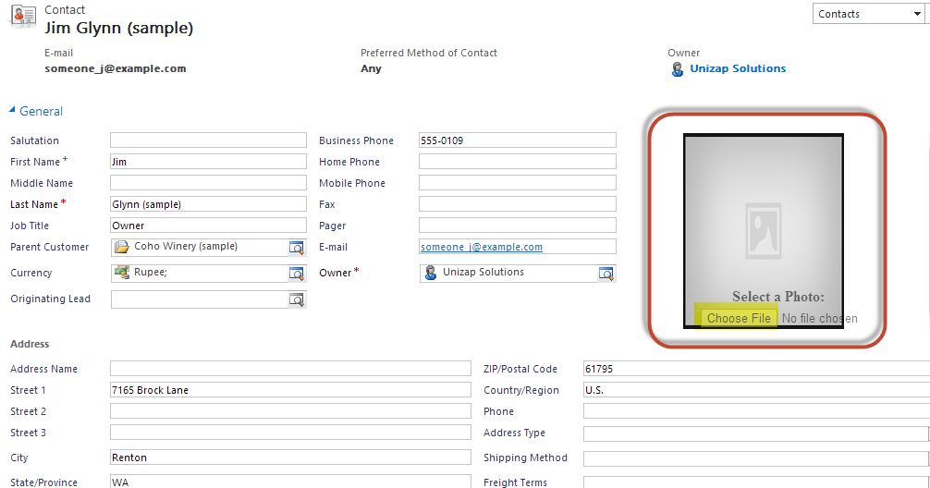
6. Choose any *.jpg* or *.png* file from your system & click Ok. Please wait while the add-on processes the image. Please do not close the window until the processing message disappears. 